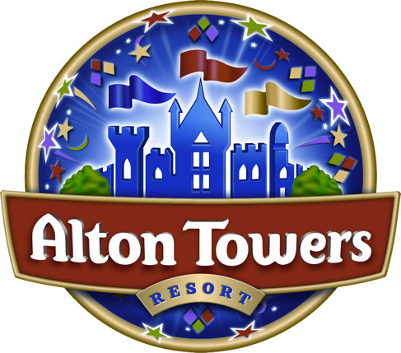 | Schools & Groups  Registration Form

We require you to register at Guest Services and give the below information in case of incident or emergency.

It is your responsibility to ensure that your mobile telephones have a good signal as some areas of the park may have poor reception.

Please note that if the teacher/group leaders are not contactable whilst on park, it will be necessary to contact the school directly. Our Medical Centre Number is: 01538 704004

Name of School/Group

Date of Visit

Bib Colour (if applicable)

Teacher/Group Leader Names | Mobile Telephone Number:
____________________  ____________________  ____________________  ____________________  ____________________  ____________________ | ____________________  ____________________  ____________________  ____________________  ____________________  ____________________
PLEASE ENSURE YOUR MOBILE TELEPHONE IS SWICTHED ON

School/Group Telephone Number

School/Group Postcode

People in Party |  |  | Time of Leaving

Emergency Meeting Point | _______________ _______________

Coach Company Name

